Training Announcement

FREE TIM Responder Training

Why this is important… Responders are being struck and killed at traffic incidents in the U.S. on average:
- 5 Firefighters each year
- 1 Law Enforcement Officer each month
- 1 Tow Truck Operator each week
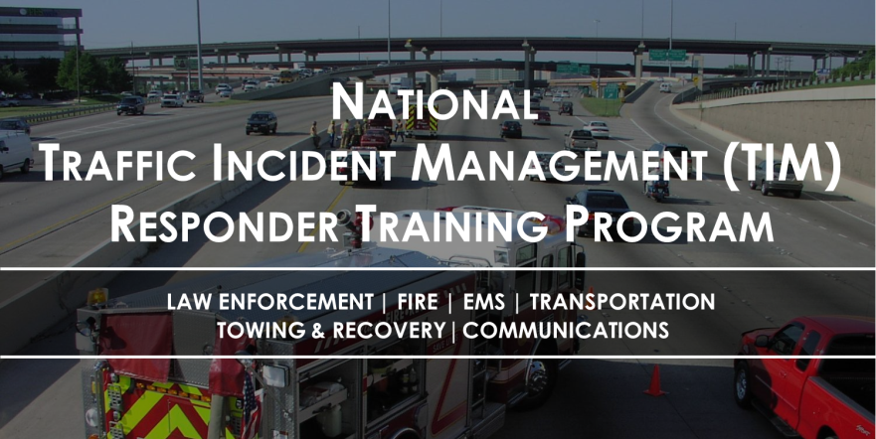

The National TIM Responder Training Program was developed by responders for responders, and was designed to establish the foundation for and promote consistent training of all responders to achieve the three objectives of the TIM National Unified Goal (NUG):
- Responder Safety
- Safe, Quick Clearance
- Prompt, Reliable, Interoperable Communications
This 4-hour condensed version of the National TIM Responder Training Program is designed to equip responders with core competencies to address responder safety on highway incidents; safe, quick clearance practices for incidents and supports prompt, reliable, interoperable communications.

The impacts of this training program includes more effective multi-agency, coordinated, and planned incident response; improved responder safety; improved travel-time reliability by improved incident clearance times; and reduced congestion, collisions, and delays caused by secondary crashes.
The target audience for this course is all TIM disciplines, including: Public Works, Law Enforcement, Fire/Rescue, Emergency Medical Service, Towing and Recovery, Emergency Management, Communications, and Highway/Transportation.
Details for the TIM 4-hour session (which is POST Certified) are as follow:
Date & Time: Wednesday, December 13, 2017 / 0800 - 1200
Location: Missouri State Highway Patrol Troop D HQ
Address: 3131 East Kearney, Springfield, MO 65803
Registration: We ask that you follow the following link to register:
http://timtraining-springfield-dec13.eventbrite.com

This training is being provided free of charge, however, agencies are responsible for all travel related expenses including lodging and meals.
REGISTRATION: If you cannot register through the on line link please contact Bruce Pettus at:
- Bruce.Pettus@modot.mo.gov or via phone at (417) 895-7688

This training has also been endorsed by the International Association of Chiefs of Police (IACP), the International Association of Fire Chiefs (IAFC), the American Association of State Highway and Transportation Officials (AASHTO), the National Volunteer Fire Council (NVFC), the International Association of Directors of Law Enforcement Standards and Training (IADLEST), and the Towing and Recovery Association of America (TRAA).

